**ABSTRACT**

Pressure vessel is leak proof vessels which have a function as container

Contain or separate hydrocarbon compound to gas and liquid Main part of pressure vessel is a cylindrical shell and head which is supported by saddle. Which on its operation, pressure vessel get much kind of loads, like internal pressure, loads because of itself weight and fluid weight. Loads that are occurred, it will be variation stress on vessel wall. The aim of this final project report is to obtain position and value maximum stress on pressure vessel. Material strength of horizontal pressure vessel is also obtained from maximum stress that is occurred

Location of maximum stress on shell part is occurs on middle of saddle edge and Location of maximum stress on head occurs on curve region. By using

Failure analysis, material can be concluded in the save condition.

|  |  |  |  |  |  |
| --- | --- | --- | --- | --- | --- |
|  | **INDEX** | | | | |
|  |  | | | | |
| **Sr. No.** | **Title** | | | | **Page No.** |
|  | **ACKNOWLEDGEMENT** | | | | 3 |
|  | **ABSTRACT** | | | | 4 |
| 1 | **COMPANY PROFILE** | | | | 6 |
| **2** | **INTRODUCTION** | | | | 11 |
|  | 2.1 | Introduction to pressure vessels | | | 11 |
|  | 2.1.1 | Classification of pressure vessels | | | 12 |
|  | 2.2 | Failure of pressure Equpements | | | 13 |
| **3.** | **DESIGN OF PRESSURE VESSEL** | | | | 16 |
|  | 3.1 | Stress analysis | | | 16 |
|  | 3.2stress /failure theories | | | | 16 |
|  | 3.3 | Loadings  3.3.1Categories of loadings  3.3.2Types of loadings | | | 17  17 |
|  | 3.4 | Stress  2.4.1Types of stress | | | 18 |
|  | 3.5Design calculation of pressure vessel | | | | 19 |
|  |  | 3.5.1 | Design of cylinder shell | | 19 |
|  |  |  |  | |  |
|  | 3.6Design data and part list for pressure vessel | | | | 47 |
|  | 3.7 Model of pressure vessels | | | | 48 |
| **4.** | **TESTING OF PRESSURE VESSELS** | | | | 53 |
|  | 4.1 Air test | | | | 53 |
|  | 4.2 | Hydro static pressure test | | | 54 |
|  | 4.3 | surface preparation and painting | | | 55 |
|  | 4.4 | post weld heat-treatment | |  | 57 |
|  | **REFERENCES** | | | | 58 |

**CHAPTER-2**

**INTRODUCTION**

**2.1 INTRODUCTION TO PRESSURE VESSELS**

Pressure vessels are leak proof containers. They may be of any shape ranging from milk bottles, gas or liquid storage tanks. The design as used here does not mean only the calculation of the detail dimensions of a member, but rather is an all inclusive term incorporating.

* The reason that establish the most likely mode of damage or failure,
* The method of stress analysis employed and significant of results and
* The selection of material type and its environmental behaviour.

The ever increasing use of vessels for storage, industrial processing and power generation under unusual conditions of pressure, temperature and environment has given special emphasis to analytical and experimental method for determining the operating stresses of equal importance appraising the meaning or significance of these stresses. This appraisal entails means of determining the value and extent of the stresses and strains, establishing the behaviour of the material involved and evaluating the compatibility of these two factors in the media or environment to which they are subjected. Knowledge of the material behaviour is required not only to avoid failures, but equally to permit maximum economy of material choice and amount used. For instance if the stresses or strains in a structure unduly low, its size becomes larger than necessary and the economic potential of the material is not reached. Developments in the space, nuclear and chemical industries have placed new demands on material suitable for extremes in temperature, impact and fatigue. Sometimes these applications also requires consideration of other environmental effects such as corrosion, neutron bombardment etc. The characteristic of materials when subjected to the action of stresses and strains are called mechanical properties.

Chemical engineering involves the applications of the process industries which are primarily concerned with the conversion of the one material into another by chemical or other means. These processes required the handling and storing of large quantities of materials in the container of the varied construction, depending upon the existing stage of the material, its physical and chemical properties, and the required operations which are to be performed. For handling such liquids and gases a container or a “vessel”, is us ed. The vessel is the basic part of most types of processing equipments. Most process equipments may be considered to be vessel with various modifications necessary to enable the units to perform certain required functions. For examples, an autoclave may be considered to be a high pressure vessel equipped with agitation and heating sources; a distillation or absorption column may be to be a vessel containing a series of vapour-liquid contactors; a heat exchanger may be consider to be a vessel containing a heat exchanger in combination with a vapour-disengaging space.

The pressure vessels are used to store fluids under pressure. The fluid being stored may undergo a change of state inside the pressure vessel as in case of steam boilers or it may be combine with other regents as in chemical plant. The pressure vessels are designed with great care because rupture of the pressure vessel means an explosion, which may cause loss of life and property. The material of the pressure vessel may be brittle, such as cast iron, or ductile such as mild steel.

**2.1.1 CLASSIFICATION OF THE PRESSURE VESSELS:**

The Pressure Vessels may be classified as follows:

* ACCORDING TO DIMENSIONS:

The Pressure Vessels, according to their dimensions, may be classified as thin shell and thick shell. If the wall thickness of the shell is less than 1/10 of the diameter of the shell, then it is said to be thin shell. Thin shells are used in boilers, tanks and pipes, where as thick shells are used in high pressure cylinders, tanks, gun metals etc.

Another criterion to classify pressure vessels as thin shell or thick shell is the internal pressure (P) and the allowable stress. If the internal fluid pressure is less than 1/6 of the allowable stress, then it is called a thin shell.

* ACCORDING TO END CONSTRUCTION:

The Pressure Vessels, according to the end constructions, may be classified as open end and closed end. A simple cylinder with a piston, such as a cylinder of a press is an example of an open end vessel, where as storage tank is an example of closed end vessel. In case of vessel having open ends, the circumferential or hoop stresses are induced by the fluid pressure, where as in case of closed ends, longitudinal stresses in additional to circumferential stresses are induced.

**A Pressure Vessel** is defined as a vessel that is subjected to either internal or external pressure. This definition generally includes air receivers, heat exchangers, evaporators, steam type sterilizers and autoclaves.

Usually the first step in the design of any vessel is the selection of the type best suited for the particular service in question. The primary factors influencing this choice are the function and the location of the vessel, the nature of the fluid, the operating temperature and pressure, and the necessary volume for storage or capacity for processing. Vessels may be classified according to functional service, temperature and pressure service, material of construction or geometry of the vessel.

The most common types of vessels may be classified according to their geometry as,

Open tanks,

* Flat-bottomed, vertical cylinder tanks,
* Vertical cylindrical and horizontal vessels with formed ends.
* Spherical or modified spherical vessel.

Vessels in each of these classifications are widely used as storage vessels as processing vessels for fluids. The range of service for the various types of vessels overlaps, and it is difficult to make distinct classification for all applications.

It is possible to indicate some generalities in existing uses of the common types of vessels. Large volumes of no hazardous liquids, such as brine and other aqueous solution may be stored in ponds if of very low value, or in open steel, wooden or concrete tanks if or greater value. If the fluid is toxic, combustible, or gaseous in the storage condition, or if the pressure is greater than atmospheric, a closed system is required. For storage of fluids at the atmospheric pressure, cylindrical tanks with flat bottoms and conical roofs are commonly used. Spheres or spheroids are employed for pressure storage where the volume required is large. For smaller volumes are more economical.

**OPEN VESSELS:**

Open vessels are commonly used as surge tanks between operations, as vats for batch operation where materials may be fixed and balanced, as setting tanks, decanters, chemical reactors, reservoirs and so on. Obviously, these types of vessels are cheaper than covered or closed vessels of the same capacity and construction. The decision as to whether or not open vessels may be used depends upon the fluid to be handled and the operation. In the process industries in general, the major portion of existing vessels are constructed of steel because of its low initial cost and ease of fabrication. In many cases such vessels are lined with lead, rubber, glass or plastic to improve resistance to corrosion.

**CLOSED VESSELS:**

Combustible fluids, fluids emitting toxic or obnoxious fumes and gases must be stored in closed vessels. Dangerous chemicals such as acid or caustic are less hazardous if stored in closed vessels. The combustible nature of petroleum and its products necessitates the use of closed vessels and tanks throughout the petroleum and petrochemical industries. The extensive use of tanks in this field has resulted in considerable efforts on the part of the American petroleum institute of standardized design for purpose of safety and economy. Tanks used for the storage of crude oils and petroleum products are generally designed and constructed in accordance with API standard 12 C, API Specifications for welded oil storage tanks.

**2.2 FAILURE OF PRESSURE EQUIPEMENTS**

There is no single, universally accepted explanation covering the way that metallic materials fail. Figure show the generally accepted phase of failure. Elastic behaviour, up to yield point, is followed by increasing amounts of irreversible plastic flow. The fracture of the material starts from the point in time at which a crack initiation occurs and continuous during the propagation phase until the material breaks.

There are several approaches to both the characteristics of the original material and the way that the material behaves at the crack tip.

Two of the more common approaches those are applicable to Pressure Vessels.

The linear elastic fracture mechanics approach with its related concept of fracture toughness parameter

Fully plastic behaviour at the crack tip, i.e. “Plastic collapse” approach.

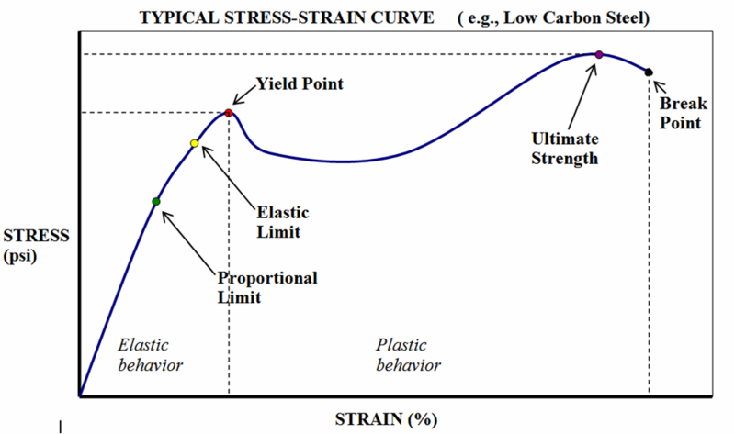

Figure Stress – Strain curve

It is necessary to understand the phenomena of pressure vessels failure in order to prevent adopting of requirement which can be self defeating, such as high factor of low toughness, which have much less forgiveness for the presence of defects, crack and propagation than do those of lower strength. We now have the knowledge in stress analysis, metallurgy and inspection techniques to rationalize their significance, rather than blindly complying with an arbitrary absolute code standards or existing rule requirement. For instance, discontinuities in the form of mechanical damage, material defects, weld shrinkage and machined undercuts may become site of high stress concentration, and subsequently main source of cyclic loading fatigue failure. Grinding such areas to restore a smooth blended surface, even though it creates minor reduction of structure thickness, will significantly restore much of the lost fatigue strength. Further such local reduction in thickness will have a negligible effect on static bursting strength of the vessels.

* *ELASTIC DEFORMATION***:** Elastic instability or elastic buckling, vessel geometry, and stiffness as well as properties of materials are protection against buckling.
* *BRITTLE FAILURE:*It can occur at low or intermediate temperature. Brittle fractures have occurred in vessels made of low carbon steel in the 40-50 F ranges during hydro test where minor flaws exist.
* *Excessive Plastic Deformation:*The primary and secondary stress limits as outlined in ASME section VIII, Division 2, are intended to prevent excessive Plastic Deformation and Incremental collapse.
* *STRESS RUPTURE:*Creep deformation as a result of fatigue or cyclic loading, i.e., progressive fracture. Creep is a time –dependent phenomenon, whereas fatigue is a cycle dependent phenomenon.
* *PLASTIC INSTABILITY:*Incremental collapse; incremental collapse is cyclic strain accumulation or cumulative cyclic deformation. Cumulative damage leads to instability of vessel by plastic deformation.
* *HIGH STRAIN:*Low cycle fatigue is strain governed and occurs mainly in lower strength / high ductile materials.
* *STRESS CORROSION:*It is well known that chlorides cause stress corrosion cracking in stainless steel, likewise caustic service can stress corrosion cracking in carbon steels. Material selection is critical in these services.
* *CORROSION FATIGUE***:** Occurs when corrosion and fatigue effects occur simultaneously. Corrosion can reduce fatigue life by pitting the surface and propagating cracks. Material selection and fatigue properties are the major considerations

**CHAPTER – 3**

**DESIGN OF PRESSURE VESSEL**

**3.1 STRESS ANALYSIS:**

Stress analysis is the determination of the relationship between external forces applied to a vessel and the corresponding stress. The emphasis of this book is not how to do stress analysis in particular, but rather how to analyze vessels and their component parts in an effort to arrive at an economical and safe design-the difference being that we analyze stresses where necessary to determine thickness of material and sizes of members. We are not so concerned with building mathematical models as with providing a step-by-step approach to the design of vessels. It is not necessary to find every stress but rather to know the governing stresses and how they relate to the vessel or its respective parts, attachments, and supports.

The starting place for stress analysis is to determine all the design conditions for a given problem and then deter- mine all the related external forces. We must then relate these external forces to the vessel parts which must resist them to find the corresponding stresses. By isolating the causes (loadings), the effects (stress) can be more accurately determined.

How these stresses are interpreted and combined, what significance they have to the overall safety of the vessel,and what allowable stresses are applied will be determined by three things:

* The strength / failure theory utilized.
* The types and categories of loadings.
* The hazard the stress represents to the vessel.

**3.2 STRESS/FAILURE THEORIES**

As stated previously, stresses are meaningless until com- pared to some stress / failure theory. The significance of a given stress must be related to its location in the vessel and its bearing on the ultimate failure of that vessel. Historically, various ‘‘theories” have been derived to combine and measure stresses against the potential failure mode. Anumber of stress theories, also called “yield criteria,” are available for describing the effects of combined stresses. For purposes of this book, as these failure theories apply to pressure vessels, only two theories will be discussed. They are the “maximum stress theory” and the “maximum shear stress theory”.

**3.3 LOADINGS**

**3.3.1 CATEGORIES OF LOADINGS:**

* *GENERAL LOADS*: Applied more or less continuously across a vessel section.
* Pressure loads: Internal or External Pressure (Design, operating, hydro test and hydrostatic head of liquid).
* Moment loads: Due to wind, seismic, erection, and transportation.
* Compressive or tensile loads: Due to dead weight, installed equipment, ladders, platforms, piping and vessel contents.
* Thermal loads: Hotbox design of skirt head attachment.
* *LOCAL LOADS:* Due to reactions from support, internals attached piping, attached equipments. i.e., platforms, mixers, etc.
* Radial load: Inward or outward.
* Shear load: Longitudinal or circumferential.
* Torsional load.
* Tangential load.
* Moment load: Longitudinal or circumferential.
* Thermal load.

**3.3.2 TYPES OF LOADINGS:**

* *STEADY LOADS:* Long term duration, continuous.
* Internal/External Pressure.
* Dead weight.
* Vessel contents.
* Loading due to attached piping and equipment.
* Loading to and from vessel supports.
* Thermal loads.
* Wind loads.
* *NON-STEADY LOADS:* Short term duration - Variable.
* Shop and field hydro tests
* Earthquake.
* Erection.
* Transportation.
* Upset, Emergency.
* Thermal loads.
* Start up / Shut down.

**3.4 STRESS**

**3.4.1 TYPES OF STRESS:**

There are many names to describe types of stress. Enough in fact to provide a confusing picture even to the experienced designer. The following list of stresses describes types of stress without regard to their effect on the vessel or component. They define a direction of stress or relate to the application of the load.

* Tensile,
* Compressive,
* Shear,
* Bending,
* Bearing,
* Axial,
* Discontinuity,
* Membrane,
* Principal,
* Thermal,
* Tangential,
* Strain induced,
* Circumferential,
* Longitudinal,
* Radial,
* Normal.
* Load induced,
* CLASSES OF STRESS:

The foregoing list provides examples of types of stress. It is, however, too general to provide a basis with which to combine stresses or apply allowable stresses. For this purpose, new groupings called classes of stress must be used. Classes of stress are defined by the type of loading which produces them and the hazard they represent to the vessel.

* PRIMARY STRESS:
* General:  
  Primary general membrane stress, Pm

Primary general bending stress, Pb

* Primary local stress, PL
* SECONDARY STRESS:
* Secondary membrane stress, Qm
* Secondary bending stress, Qb

**3.5DESIGN CALCULATION OF PRESSURE VESSEL**

**3.5.1 DESIGN OF CYLINDER SHELL:**

=Shell Thickness

=Weld Efficiency = 0.7



= Pressure



=



= Maximum Allowable Stress



= 118000



=



= Inner Diameter = 700 mm



For both higher temperature and pressure.

*Expected Thickness + Corrosion Factor*



= 4 + 0

= 4 *mm*



The value of Allowable Pressure is greater than the Design Pressure.



Here, all the values are coming in the permissible region, the design for the shell is safe.

CALCULATION OF HOOP STRAIN:

= Outer Diameter = 708 mm



A Thin Cylinder fails due to Stress development in following two sections:

Stress in Tangential direction called Hoop Stress or Circumferential Stress (σt),

Stress in Longitudinal direction (σl).

Now,

Hoop Stress or Tangential Stress or Circumferential Stress:



Longitudinal Stress:



Now, this area can be developed to a rectangle of area to A,



For Thin Cylinders having no joints, it can be seen that,

The Stress developed is independent of Length.

The Hoop Stress is more than the Longitudinal Stress and hence the design should be based on that.

**3.6 DESIGN DATA AND PART LIST FOR PRESSURE VESSEL**

|  |  |
| --- | --- |
| **DESIGN DATA** | |
| **DESIGN CODE: ASME SECTION VIII, DIVISION 1** | |
| **INSPECTION BY: ALEMBIC LIMITED API PANELAV** | |
| **OPERATING MEDIUM** | SOLVENT |
| **SPECIFIC GRAVITY** | 0.8 TO 1.3 |
| **CAPACITY STORAGE** | 300 Ltr |
| **CAPACITY DESIGN** | 300 Ltr. APPROX. |
| **DESIGN PRESSURE kg / cm2** | 4.2 FULL OF VACUUM |
| **DESIGN TEMPERATURE °C** | 100 |
| **OPERATING PRESSURE kg / cm2** | 3.5 FULL OF VACUUM |
| **OPERATING TEMPERATURE °C** | 30 TO 50 |
| **HYD. TEST PRESSURE kg / cm2** | 6.3 |
| **CORROSION ALLOWANCE mm** | NIL |
| **RADIOGRAPHY SHELL / DISH** | - |

Table I: Design data

**3.7 MODEL OF PRESSURE VESSLE**

Figure : Assembly of Pressure Vessel

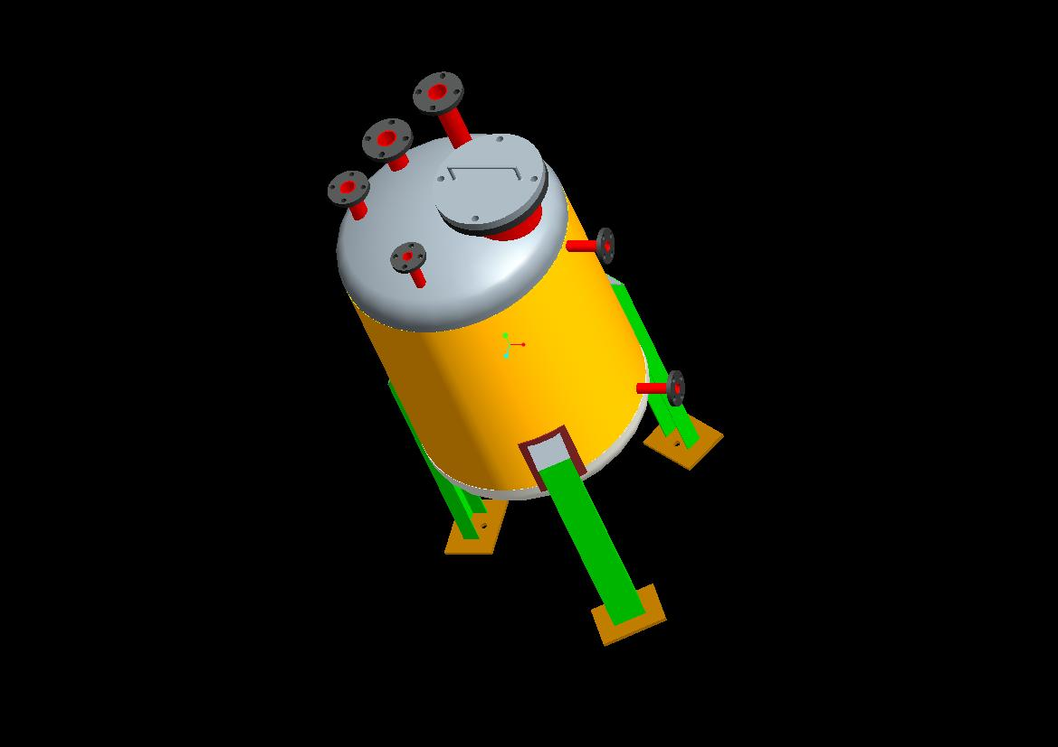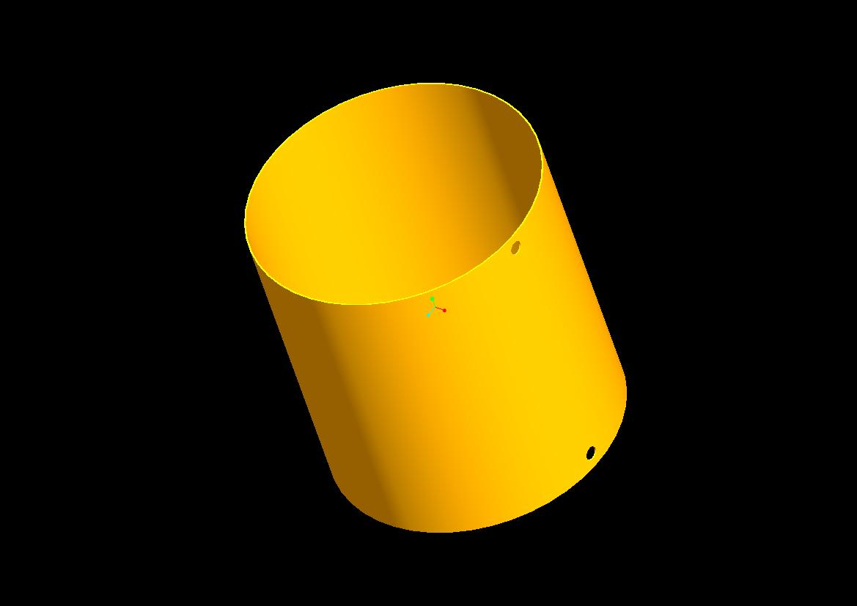

Figure : Main shell

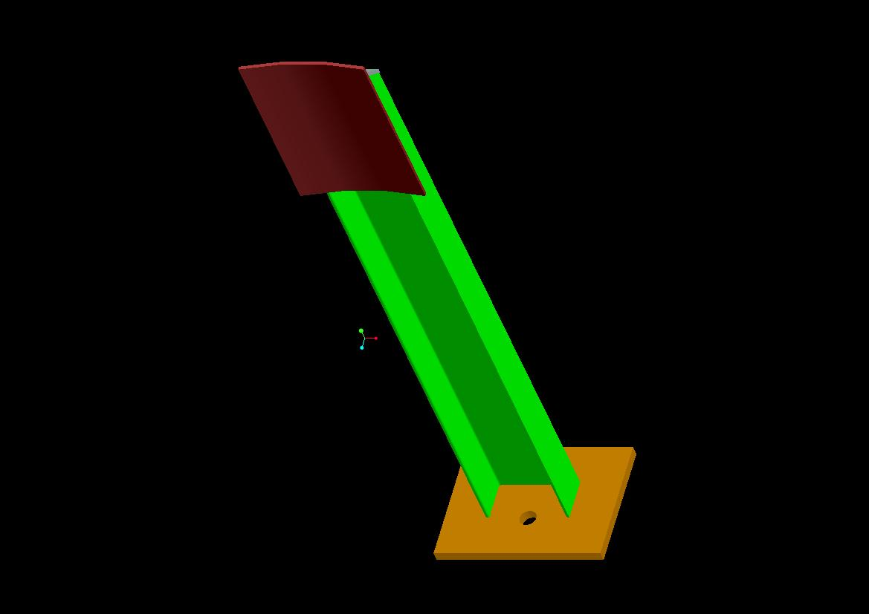

Figure : Leg Assembly

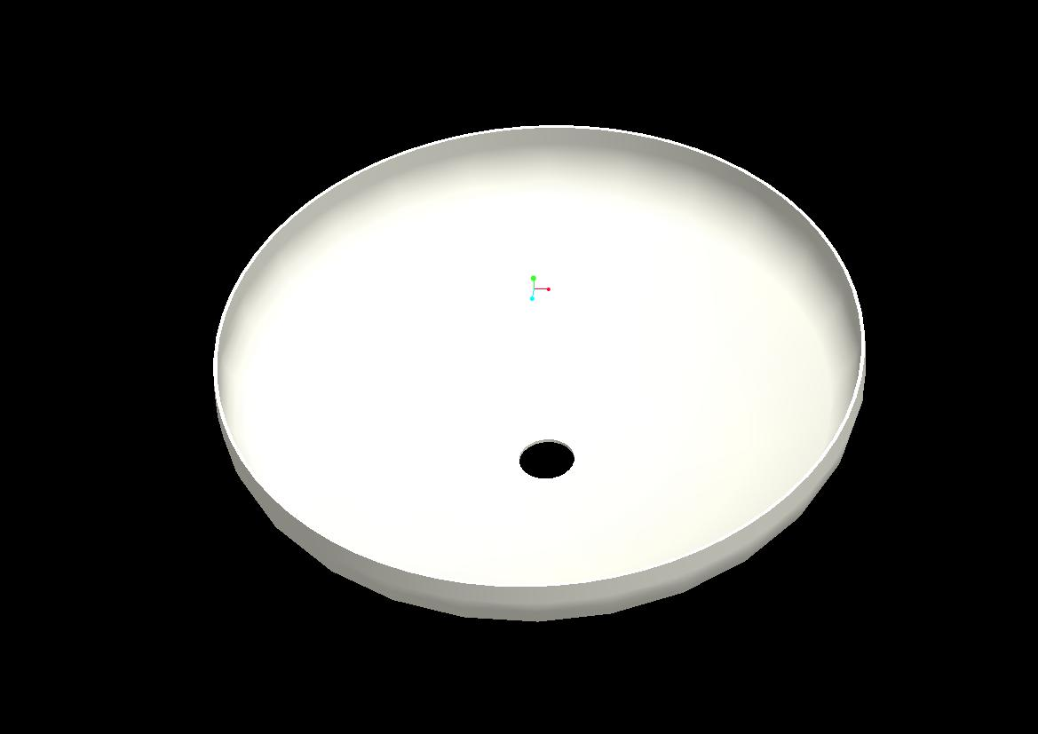

Figure : Bottom Dish

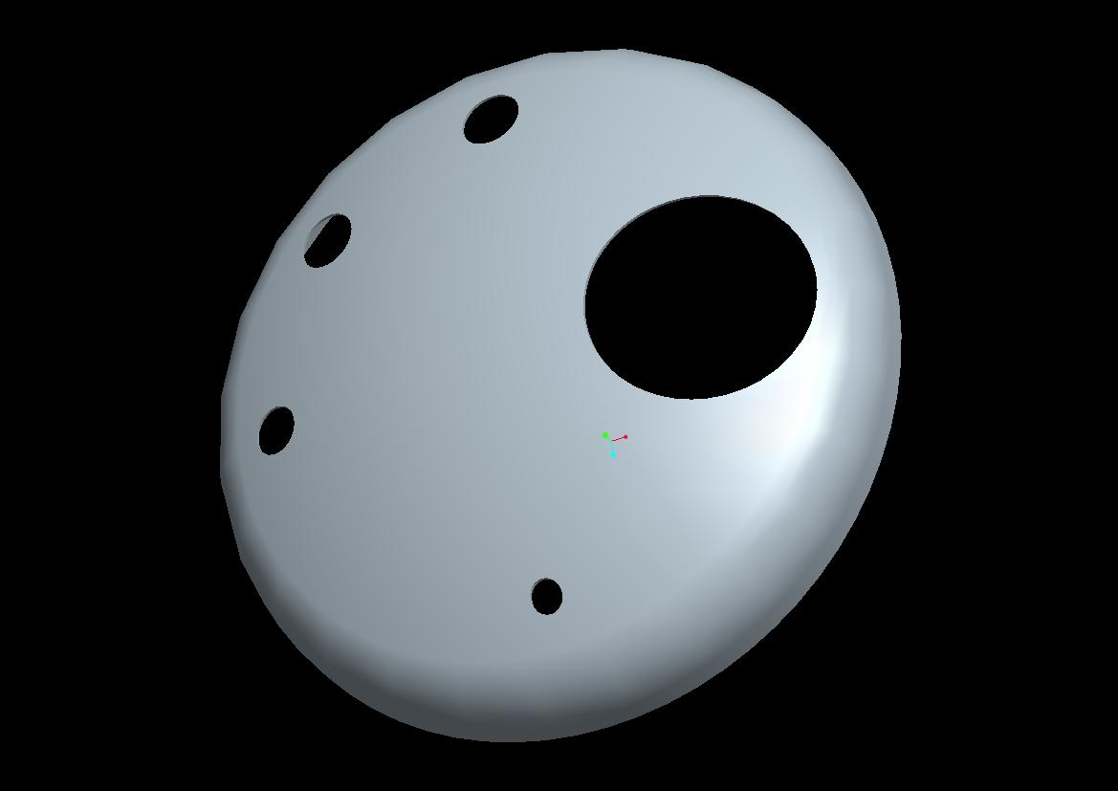

Figure : Top Dish

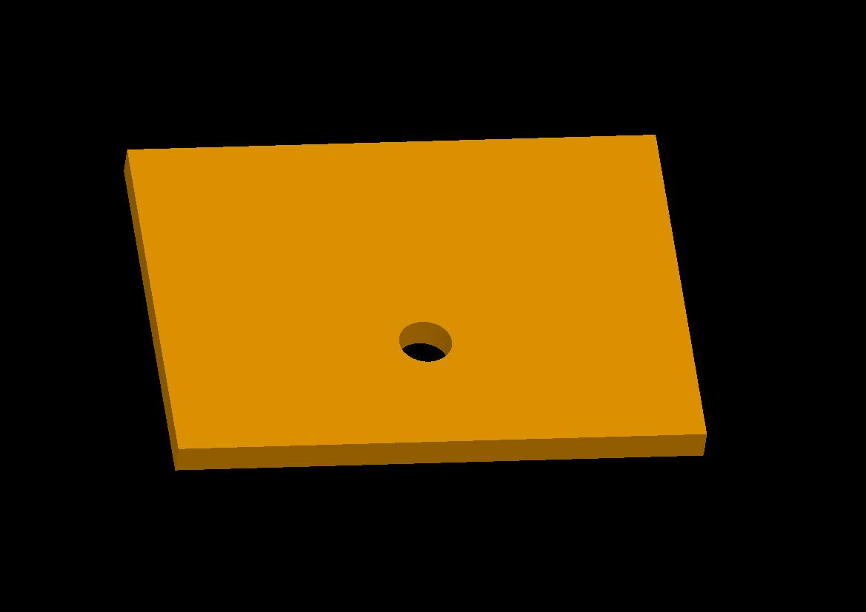

Figure: Leg support 1

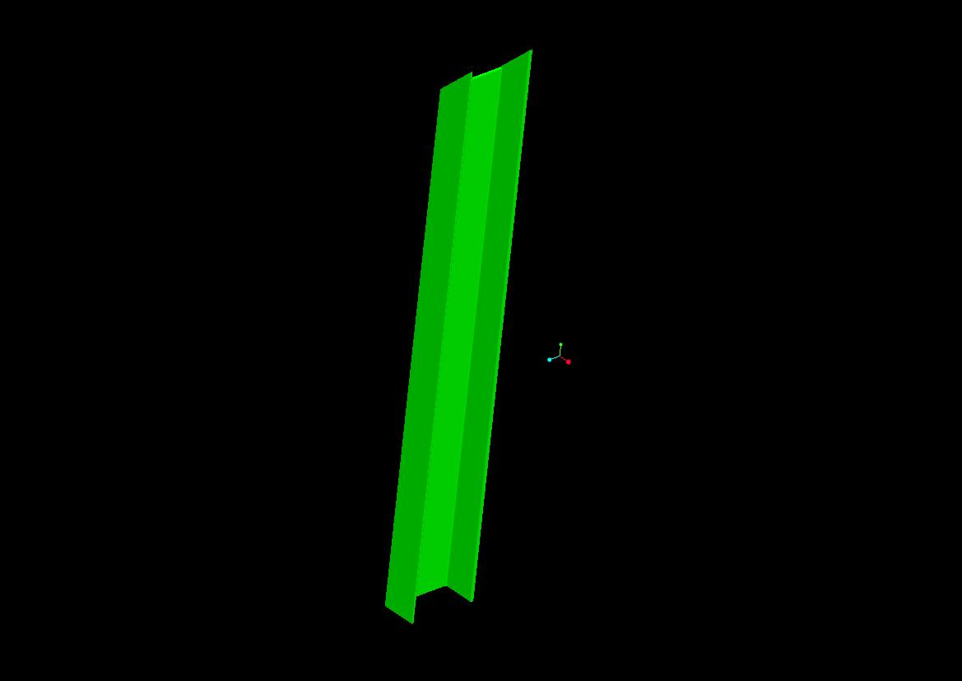

Figure : Leg support 2 (C Channel)

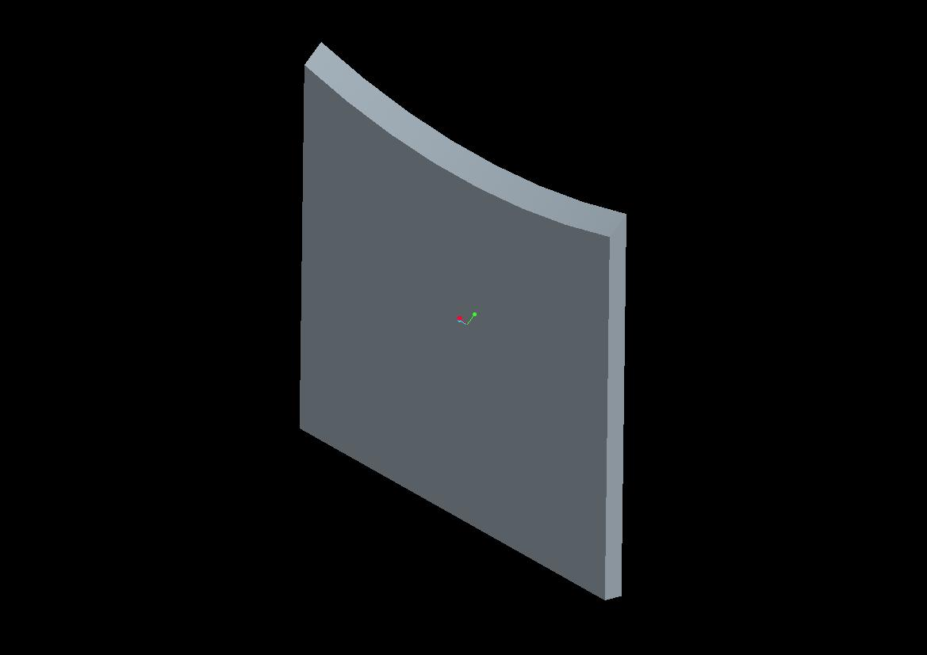

Figure : Leg support cover plate

Figure : Nozzle 2 Assembly

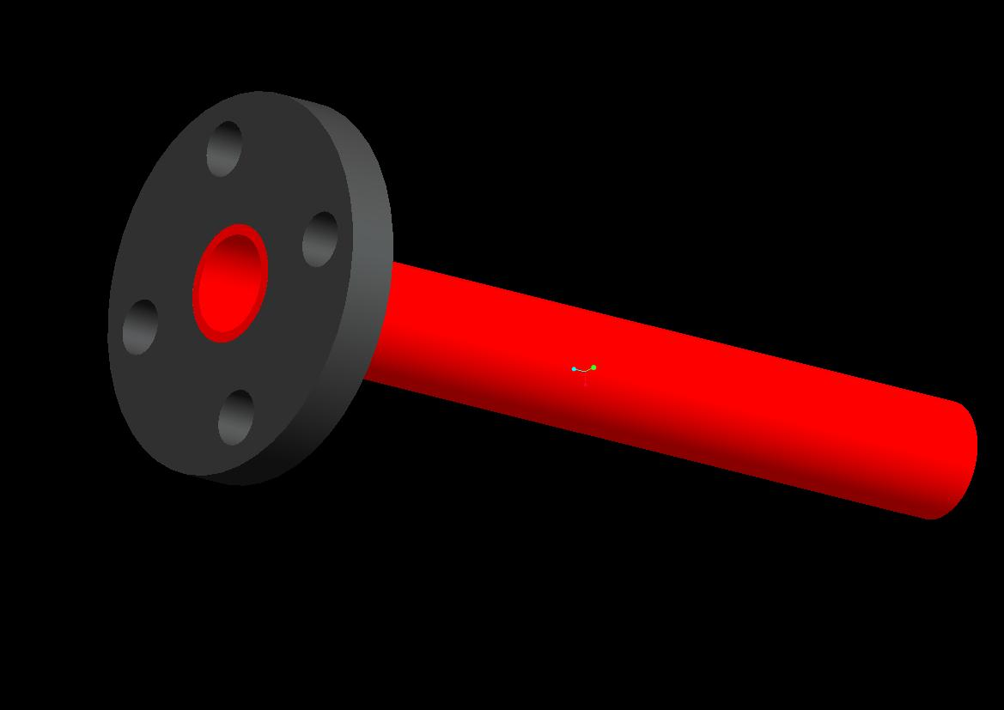

**CHAPTER – 4 TESTING OF PRESSURE VESSELS**

There are various types of tests are performed on the Pressure Vessels after

fabrication to check that whether it is ok or not. These various tests are:

1. Air Test
2. Hydro Static Pressure Test
3. Surface Preparation and Painting

**4.1 AIR TEST**

* **SCOPE:**
* To check the leak tightness of the any RF Fad after completion of

welding as per drawing [59].

* **PROCEDURE:**
* Penetrant examination of completion of comp0lete welding to RF Pad
* shall be carried out before Pneumatic test / Hydro Test.
* The area of interest for examination shall be accessible and sufficient
* Lighting facility shall be ensured.
* Oil free dry Nitrogen or Air shall be used as pressurizing media.
* Connect pressure gauge having range 1.0 to 4 times test pressure and with valid calibration status.
* Connect above pressure gauge to tap tale hole.
* Gradually increase pressure to 1.05Kg/Cm2 (g) [Test Pressure] &examine for leakage using soap solution.
* Release the pressure slowly after test is completed.
* Disconnect the pressure test connection.
* **ACCEPTANCE CRITERIA:**

No bubble formation due to leakage permitted.

**4.2 HYDRO STATIC PRESSURE TEST:**

* **SCOPE:**
* This governs the performance of the initial pressure test of equipment.
* By means of the pressure test it will be determined whether the pressure

retaining walls are leak tight when exposed to test pressure and whether

any deformations occur which are occur critical as regards safety.

* **PRE-OPERATION CHECK:**
* Hydrostatic test shall be carried out by only after completion of following
* operations.
* Radiographic examinations of applicable weld joints.
* Penetrant examinations of applicable weld joints
* All welding attachments to the inner vessel.
* Removal of any other attachments other than that given in drawing.
* Dimensional and visual examination.
* Air leak test of reinforcement’s pads.
* Test may be carried out in vertical / horizontal position. During
* processing following points should be checked.
* Use clean water with chloride content as mentioned in approved
* Drawing.
* Connect at least 2 pressure gauges. One represents the top of vessel and
* another represents the bottom of vessel. The pressure gauges shall be of
* suitable range (1.5 to 4 times of test pressure) and valid calibration.
* Completely vent pressure chamber during filling, then seal vents.
* Measure the outside circumference before pressurizing. It shall be noted
* during pressure and after release of pressure. Any abnormal change in
* dimensions shall be brought to notice of visiting inspector.
* Examine all the joints for any leakage.
* Increase the pressure slowly and continuously till the test pressure
* teacher.
* Mark the pressure indicated on the gauge.
* Hold the pressure for minimum 30 minutes.
* Examine all the joints for leakage/ unusual expansion.
* Release the pressure.
* Check the pressure gauge after releasing pressure and confirm that needle
* comes to zero.
* Vents before draining.
* Water shall be removed immediately after testing.
* **ACCEPTANCE CRITERIA:**
* No leakage or distortion is permitted.

**4.3 SURFACE PREPARATION AND PAINTING**

* **SCOPE:**

The specification is for dry abrasive blast cleaning and protective coating requirement for painting of carbon steel vessels, tanks and other components.

* **CLEANING PRIOR TO BLASTING:**

Before starting the blasting external surface(which are subject to contact with oil/grease during NDT) shall be cleaned for visible deposit of oil or grease by solvent (soft detergent-0.5% solution or power wire brushing in accordance with SSPCSP-1(Thinner is not to be used)

* **SURFACE BLAST CLEANING:**

After solvent cleaning, surface of equipment shall be blast cleaned to(near white blast cleaning Sa-2.5 and internal surface to Sa 3) (dry abrasive blasting using compressed air, blast nozzles and using sharp angular abrasive.) SHRENO proposes to use sand.

A near white blast cleaning means surface, when viewed without magnification shall be free of all visible oil, grease, dust, mill scale, coating, oxides, corrosion product and foreign matter.

For achieving clean and dry compressed air, oil and water filter shall be provided on the outlet of the compressor. Also an oil filter shall be provided close to the blast/spray gun.

Any visible rust that forms on the surface of the steel after blast cleaning shall be removed by re-blasting. The cleaned area shall meet the requirement of the standard before coating.

Abrasive shall not be recycled and new abrasive shall be used for blasting. For stainless steel, only aluminium oxide or nor metallic abrasives shall be used.

* **INSPECTION FOR BLAST CLEANING:**

Periodic check minimum 3 times in a day for moisture and dew point should be carried out during blast cleaning operation, priming and final painting. The

temperature of steel surface should be at least 5 F (3º C) above the dew point during dry blast cleaning operation.

Visual inspection for mill scale and rust shall be carried out as per SSPC-VIS-1-89 by comparing the blast cleaned surface with photograph/s.

**4.4 POST WELD HEAT-TREATMENT**

* **SCOPE:**

This procedure covers the method of heat treatment to be carried out on vessel / vessel part or weldment including repair weld when referenced by code of construction / drawing / specification.

* **PRE-OPERATION CHECK:**

Heat – treatment shall be carried out strictly in accordance with cycle approval.

Post weld heat – treatment, when required, shall be done before hydrostatic test and after any welded repairs.

Before applying the detailed requirement of UCS – 56, satisfactory weld procedures to be used shall be performed in accordance with all the essential variables of ASME SEC.IX including conditions of post weld heat – treatment or lack of post weld – treatment.

Based on size and shape of vessel being heat-treated, all care shall be taken to support the vessel/vessel parts, to avoid distortions due to heat – treatment.

Where more than one pressure vessel or pressure vessel part are post weld heat treated in one furnace charge, themocouples shall be placed on vessels at the bottom, centre and top of the charge, or in other zones of possible temperature for all vessels or parts in those zones.

It shall be ensured that thermocouples are placed in contact with vessel or vessel parts to indicate actual metal temperature (Recommended As Per Annexure).

Sufficient number of thermocouples shall be placed in such a manner that uniform temperature can be ensured.

Before start of heat – treatment, it shall be ensured that calibration of all thermocouples and temperature recorder is valid.

* **PROCEDURE FOR HEAT TREAMENT :**

When heat-treatment or post weld heat treatment is required by reference code drawing or specification, it shall be carried out by using one of the procedures given in UW – 40 of ASME Sec. VIII Div. - 1.

* *SOAK BEND :*

Soak band is a volume of metal required to meet or exceed the minimum PWHT temperature.

As a minimum, the soak band shall contain the weld, HAZ and a portion of base metal adjacent to the weld being heat – treated.

The minimum width of this volume is the widest width of weld plus 1 X T or 2 inch (51 mm), whichever is less, on each side or end of the weld. The term is the nominal thickness as defined in UW – 40 (f).

* **HEAT TREATMENT CYCLE:**

The temperature of the furnace shall not exceed 400º C at the time of part is

placed in it.

Above 400º C the rate of heating shall not be more than 200ºC /Hr. divided

by the maximum metal thickness of the shell or head plate in inches, but in no

case more than 400º F/Hr.(222º C/Hr.)

During the heating period there shall not be a greater variation in temperature

throughout the portion of the vessel being heated than 250 ºF (139º C) with in

any 15 ft (4.6m) interval of length.

The vessel or part shall be held at or above the temperature & hold for time

specified in UCS – 5+ / Drawing.

During the holding period there shall not be a greater difference than 150º F (83ºC) between the highest and lower temperature throughout the portion of the vessel being heated except where the portion of the vessel being heated except where the range is further limited in table UCS – 56.

During the heating and holding periods, the furnace atmosphere shall be so

controlled as to avoid excessive oxidation of the surface of the vessel. The furnace of the vessel. The furnace shall be of such design as to prevent direct impingement of the flam on the vessel.

Above 800º F(427º), cooling shall be done in a closed or cooling chamber at a

rate not greater than 500º F/Hr. divided by the maximum metal thickness of the shell or head plate in inches , but in case more than 500º F/Hr. (278ºC). Form 800º F (427º C), the vessel may be cooled in still air.

The rate of heating & cooling need not be less than 100º F/Hr. If not exempted by code, vessel or parts of vessel that have been post weld heat treatment shall be again post weld heat treated after welded repairs have been made.

* **POST – OPERATION CHECK:**

A time – temp. Diagram along with calibration certificates shall be reviewed

by INSPECTOR / AGENCY.

The visual check for any damage/distortion shall be carried out.